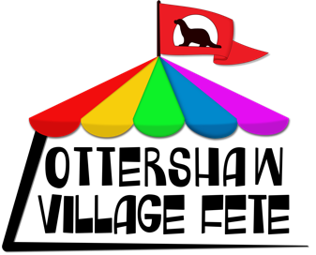
Ottershaw Village Fete
Saturday 28th June 2025 1-5pm
Ottershaw Memorial Playing Fields
Ottershaw KT16 0NQ.

PITCH APPLICATION – RISK ASSESSMENT TEMPLATE

PLEASE COMPLETE THE RISK ASSESSMENT AND SUBMIT WITH YOUR APPLICATION. IF YOU HAVE YOUR OWN RISK ASSESMENT, YOU CAN SEND US THIS, AS LONG AS IT COVERS THE SAME TOPICS.

Subjects that should be covered have been listed. You may have others specifically relating to your stall.

Subject | List of potential hazards | Who might be harmed and how? | Evaluate the risks and describe precautions
Setting up / striking stall
Layout of stall -stallholders safety
Layout of stall – public safety
Products on sale- risks
Any activities
Handling of money
Health and welfare
Other specific to your stall

Name of stall or pitch activity:

Name of pitch applicant:

Signed by person conducting assessment: Date:

Please let us know as soon as possible if any changes need to be made to your assessment ahead of the fete.

